CRYSTAL SERENITY CRUISE
EUROPE & MEDITERRANEAN
Marseille – Civitavecchia (Rome)
02 - 10 JUN 2026

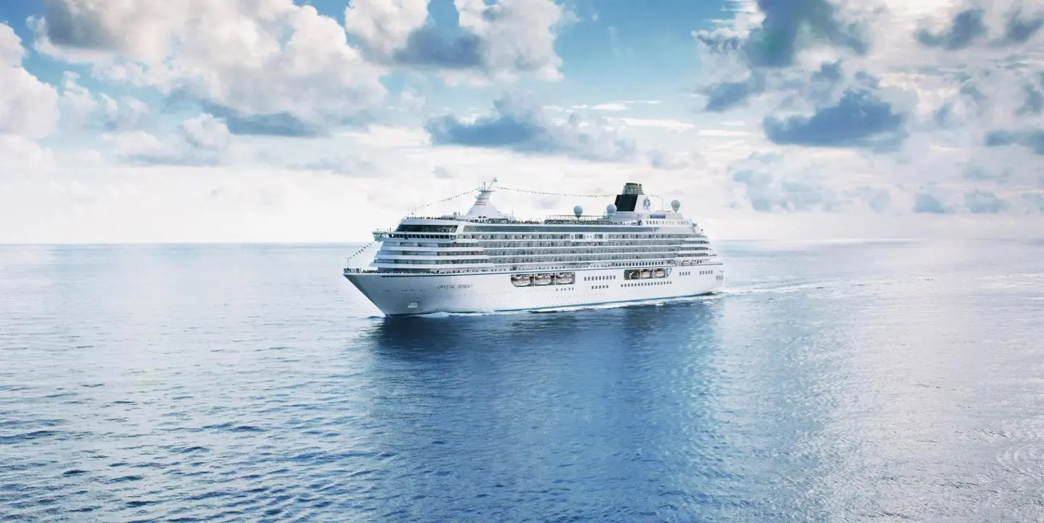

Itinerary
01. Marseille JUN 02, 2026
FRANCE
02. PORTO MAHON JUn 03, 2026
SPAIN 09:00 - 19:00
03.BARCELONA JUn 04, 2026
SPAIN 08:00 - 19:00
04.DAY AT SEA JUn 05, 2026
05.MONTE CARLO JUn 06, 2026
MONACO 07:00 - 23:59

06.VILLEFRANCHE-SUR-MER JUn 07, 2026
FRANCE 07:00 - 22:00
07.PORTOVENERE JUn 08, 2026
ITALY 08:00 - 19:00

08. livorno (tuscany) JUn 09, 2026
italy 07:00 - 19:00
09.civitavecchia (rome) JUn 10, 20256
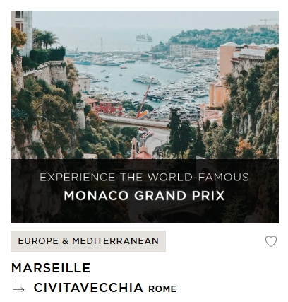
italy
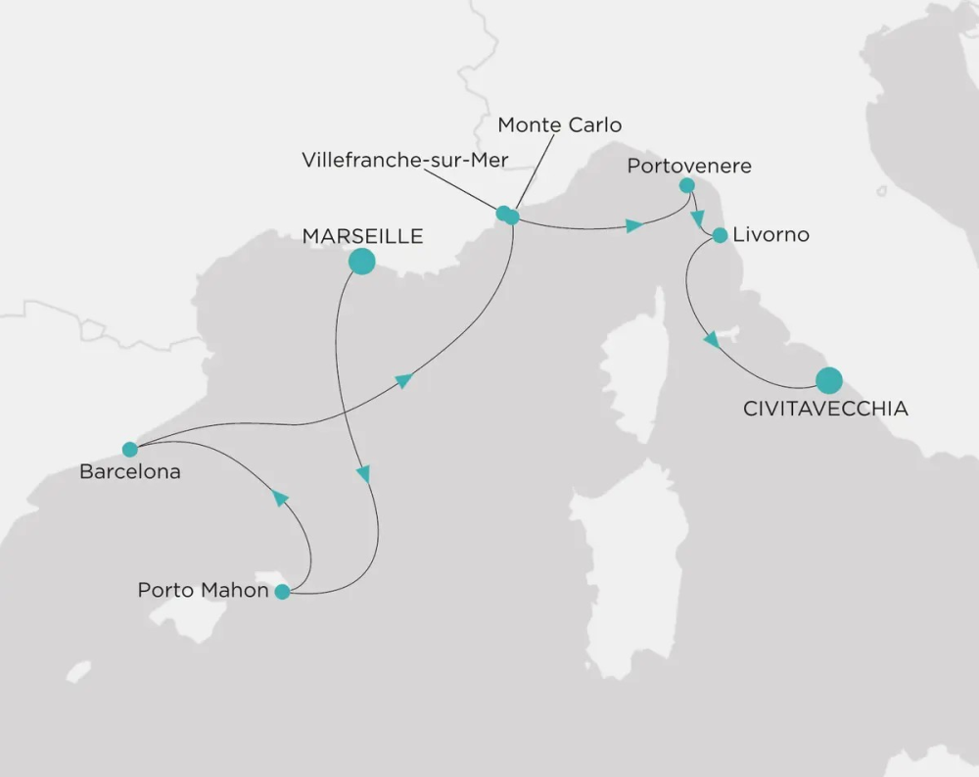

GUEST CAPACITY 740
STAFF TO GUEST RATIONEARLY ONE STAFF MEMBER PER GUEST
refurbished 2023
GROSS REGISTERED TONS 68,870
LENGTH 820 FT (250 M)
WIDTH 105.6 FT (32.2 M)
DRAFT 24.9 FT (7.6 M)
CRUISING SPEED MAX 22 KNOTS

DINING
Dining with Crystal is the ultimate culinary experience. With nine distinct options, we offer
the best food for whatever suits your mood. Enjoy everything from award-winning, innovative fusion
cuisine and signature cocktail bars to the best of traditional food and wine.
UMI UMA BY NOBU MATSUHISA RESTAURANT AND SUSHI BAR
RESERVATIONS REQUIRED AND LIMITED PER SAILING | SEATS: 60
Few restaurants can boast a creative vision of contemporary cuisine
as Nobu. Prepare to lose yourself in the beautiful decor and signature
Japanese-Peruvian dishes.
OSTERIA D’OVIDIO
RESERVATIONS REQUIRED AND LIMITED PER SAILING | SEATS: 94
Fine Italian dining takes center stage at Osteria d’Ovidio. This exclusive
specialty restaurant offers a modern twist on traditional fine Italian cuisine
in a sleek and spacious reimagined venue.
WATERSIDE RESTAURANT | SEATS: 468
Take your tastebuds on a tour of our modern, international cuisine options.
Enjoy creative, seasonal dishes in an elegant setting with beautiful ocean views.

THE BISTRO | SEATS: 60
A nod to the mythic bars and bistros of Paris. Celebrate the classics in
this spacious and airy cafe that serves light bites from dawn to dusk.

THE VINTAGE ROOM | RESERVATIONS REQUIRED | SEATS: 14
A unique gourmet food and wine pairing restaurant that offers an educational
dining experience while enjoying some of the best vintages at sea.
TRIDENT GRILL | SEATS: 119
Enjoy a burger with a view! Our pool restaurant and grill offers a comfortable
terrace highlighted by an elegant design, making it the perfect spot for
al fresco dining.
TASTES KITCHEN & BAR | OPEN SEATING | SEATS: 105
A new definition of traveling with taste. Sumptuous, regionally inspired tapas-style
cuisine is the perfect combination of sophisticated style and casual dining.
SCOOPS ICE CREAM BAR
Authentic Italian gelato with a sea view. Choose from must-try innovative flavors
or traditional tried and tested delights.
MARKETPLACE | OPEN SEATING | SEATS: 230
This sophisticated buffet-style restaurant features a dizzying array of hot
and cold choices for those who like a little of everything.
24-HOUR IN-SUITE DINING
Enjoy a meal from the comfort of your suite. Select from a variety of options
to delight you while you stay in, watch a movie, or read a favorite book.
WELLNESS
We believe a balanced time aboard makes for a voyage well spent. Aurōra Spa offers
sauna and steam rooms accompanied by a broad range of treatments, while our TechnogymR
fitness center comes with a full-time instructor available for personalized sessions
FITNESS CENTER
Our 3,000+ square-foot Fitness Center, Weight Room, and Aerobics Studio
feature an extensive line of professional weights and TechnogymR exercise
equipment, along with panoramic views. We also offer a Wellness program
with classes in yoga, mat Pilates, and spin classes. Our ships’ full-time Fitness
Director offers fitness advice and a variety of stretch and aerobic instruction.
AURŌRA SPA
Crystal’s new Aurōra Spa embodies the powers of the Goddess of Dawn,
who renews herself every morning and streaks across the sky to announce
the arrival of the sun. Our expert technicians and therapists offer
sunrise-inspired signature treatments blending technology and touch,
ensuring head-to-toe rejuvenation.
TABLE TENNIS
Challenge a friend to a fun game of ping-pong on one of our tennis tables.
WIMBLEDON COURT (PADDLE TENNIS AND PICKLE BALL)
Hit the full-sized paddle tennis and pickle ball court for a friendly game.

ENTERTAINMENT
Each evening Crystal brings together a cast of world-class performers, entertainers, and hosts.
Whether you’re looking for theatrical entertainment or the latest Hollywood release, our lounges,
ballrooms, night clubs, and screening rooms can cater to your every mood.
AVENUE SALOON | SEATS: 69
Our signature piano bar with an intimate ambience. The perfect setting
for a cocktail before and after dinner.
GALAXY LOUNGE | SEATS: 565
Performances are the focal point here, with appearances by fantastic
Broadway-style performers and headline entertainers. Drink service
provided before each show.
HOLLYWOOD THEATRE | SEATS: 202
The ship’s sleek cinema for recent-released movies, live sport events,
guest lectures, and religious services.
PULSE NIGHT CLUB | SEATS: 45
An intimate lounge for a late-night drink, dancing, or a place to
let loose with karaoke.
STARDUST NIGHT CLUB AND SUPPER CLUB | SEATS: 116
On select evenings before and after dinner, this entertainment lounge
features dancing, cabaret performances, and other themed events.
Additionally, on select nights, Stardust will open the doors for Supper Club
for guests to enjoy an evening show where they can dine and dance at the
same time. Supper Club is by reservations only.

PUBLIC SPACES
Our elegant vessel hosts an exceptional offering of world-renowned restaurants,
restorative spas, and endless opportunity for inspiration and enrichment, tied together
by unparalleled personal service.
APROPOS & FACETS ONBOARD SHOPPING
Heighten the experience on board with a selection of fine jewelry, watches,
and cruise wear available, alongside designer apparel. Make the most of
being at sea with a selection of duty-free items.
COMPUTER UNIVERSITY@SEA | SEATS: 24
Our innovative Computer lab onboard led by a team of tech experts.
CONNOISSEUR CLUB | SEATS: 20
An elegant space to indulge in the finest cigars and cognacs.
CRYSTAL COVE | SEATS: 62
An ideal refreshment stop any time of the day, and the perfect place
to meet friends for a pre-dinner cocktail. Enjoy a variety of musical styles
as the day turns into night.
LIBRARY
A well-stocked library containing over 2,000 books on a range of subjects
from classics to popular biographies, and history to contemporary mysteries.
Plus, enjoy an ample selection of magazines and board games perfect for
poolside reading.
PALM COURT | SEATS: 166
Featuring large sky lights, floor-to-ceiling windows, and a fabulous
270-degree forward view, this venue is perfect for afternoon tea,
social gatherings, and dancing.
SEAHORSE POOL
Our lap pool with plenty of surrounding deck space to sunbathe,
relax, and read while enjoying a cool drink in the afternoon.
THE STUDIO | SEATS: 52
Enjoy lectures and enriching experiences in this intimate
classroom setting.
WAVE’S TEEN CENTER &
FANTASIA CHILDREN’S PLAYROOM
Specialized fun for junior cruisers.

ราคาห้องพัก
CRYSTAL PENTHOUSE SUITE | ราคาต่อท่าน
พัก 1 ท่าน | 38,400 USD
พัก 2 ท่าน | 20,400 USD
ห้องพักขึ้นอยู่กับจำนวนห้องที่เหลืออยู่และอัตราแลกเปลี่ยน USD
ราคาห้องพักที่แสดงเป็นราคาเริ่มต้นเท่านั้น ราคาต้องทำการ Request a quote ทุกครั้งที่ทำการจอง
CRYSTAL PENTHOUSE SUITE
SUITE UP TO 1,265 SQ FT | VERANDA UP TO 107 SQ FT
Our largest suite, with expansive living areas, a private veranda, sumptuous
finishings, and attentive butler service.
• Large private veranda with teak furniture
• Spacious living room and separate dining area with ocean view and binoculars
• Separate den with full-size sleeper sofa, TV, and closet
• Butler’s pantry with refrigerator and espresso/cappuccino machine
• Large bedroom with queen-size bed or twins and sumptous bedding
• Master bath featuring a television, Duravit spa flotation tub with ocean view,
and state-of-the-art shower with customized shower direction and a heated
bench, plus bidet
• Master walk-in closet with illuminated rods and custom shelving
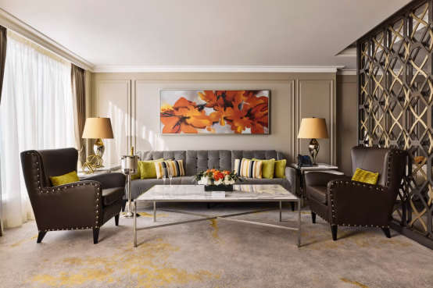
• Guest bathroom
• Sophisticated one-touch lighting and surround-sound system
• Room service from Umi Uma and Osteria d’Ovidio
• Unlimited dining in Osteria d’Ovidio and Umi Uma (by reservation,
based on space availability)
• Complimentary unlimited laundry and dry cleaning, 2nd day service
• Private transfer to and from the ship up to 50 miles
• Butler or Concierge escort from terminal to a suite on embarkation day
• In-suite cocktail parties
• Fresh flowers and afternoon canapes

ราคาห้องพัก
JUNIOR CRYSTAL PENTHOUSE SUITE | ราคาต่อท่าน
พัก 1 ท่าน | 30,000 USD
พัก 2 ท่าน | 16,000 USD
ห้องพักขึ้นอยู่กับจำนวนห้องที่เหลืออยู่และอัตราแลกเปลี่ยน USD
ราคาห้องพักที่แสดงเป็นราคาเริ่มต้นเท่านั้น ราคาต้องทำการ Request a quote ทุกครั้งที่ทำการจอง
JUNIOR CRYSTAL PENTHOUSE SUITE
SUITE UP TO 645 SQ FT | VERANDA 161 SQ FT
Newly redesigned in 2023, this large suite includes spacious rooms
with separate dining and living areas, looking onto a private veranda,
and accompanied by attentive butler service.
• Large private veranda
• Spacious living room with TV, and dining area
• Separate bedroom area with TV
• Vanity in bedroom
• Queen-size bed or twin beds with sumptuous bedding, and a third berth
• Full whirlpool bathtub, separate shower, and bidet
• Walk-in closet
• Room service from Umi Uma and Osteria d’Ovidio
• Unlimited dining in Osteria d’Ovidio and Umi Uma (by reservation,
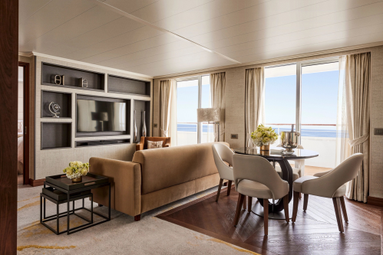
based on space availability)
• Turndown service with handmade truffles
• In-suite cocktail parties
• Dry cleaning for five pieces plus one complimentary bag of laundry
every 10 cruise days, 2nd day service
• Complimentary pressing (5pcs/day), 2nd day service
• Private transfer to and from ship up to 50 miles
• Butler or Concierge escort from terminal to suite on embarkation day
• Fresh flowers and afternoon canapes
• Nespresso coffee maker
• Binoculars

ราคาห้องพัก
SAPPHIRE VERANDA SUITE | ราคาต่อท่าน
พัก 1 ท่าน | 13,200 USD
พัก 2 ท่าน | 8,600 USD
ห้องพักขึ้นอยู่กับจำนวนห้องที่เหลืออยู่และอัตราแลกเปลี่ยน USD
ราคาห้องพักที่แสดงเป็นราคาเริ่มต้นเท่านั้น ราคาต้องทำการ Request a quote ทุกครั้งที่ทำการจอง
SAPPHIRE VERANDA SUITE
SUITE UP TO 430 SQ FT | VERANDA UP TO 107 SQ FT
Spacious suite with living area, elegant finishings, and private veranda,
accompanied by attentive butler service. Sapphire suites are available
to book in 2023, 2018, and classic designs.
• Private veranda
• Spacious living room and dining area
• Queen-size bed or twin beds with sumptuous bedding, and a third berth
• Walk-in closet
• Two TV’s
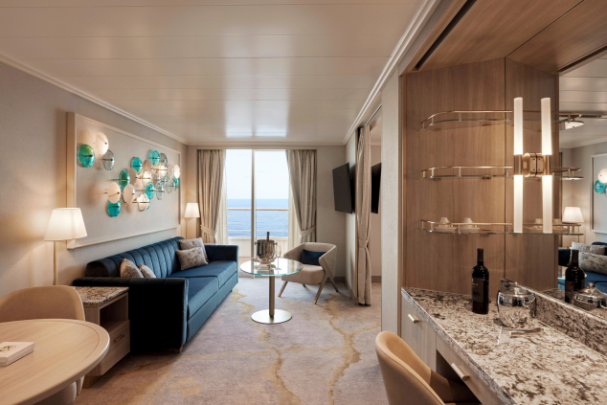
• Washer and dryer combo available in select suites
• Classic suite features a separate soaking bathtub
• Classic and 2018 suites include a bidet
• Turndown service with handmade truffles
• Dry cleaning for five pieces plus one complimentary bag of laundry
every 10 cruise days, 2nd day service
• Complimentary pressing (5pcs/day), 2nd day service
• Fresh flowers and afternoon canapes
• Nespresso coffee maker
• Binoculars

ราคาห้องพัก
AQUAMARINE VERANDA SUITE | ราคาต่อท่าน
พัก 1 ท่าน | 10,700 USD
พัก 2 ท่าน | 7,100 USD
ห้องพักขึ้นอยู่กับจำนวนห้องที่เหลืออยู่และอัตราแลกเปลี่ยน USD
ราคาห้องพักที่แสดงเป็นราคาเริ่มต้นเท่านั้น ราคาต้องทำการ Request a quote ทุกครั้งที่ทำการจอง

AQUAMARINE VERANDA SUITE
SUITE UP TO 323 SQ | VERANDA UP TO 86 SQ FT
Suite offering a comfortable living area, private veranda, and perfect
for grand yet intimate moments, accompanied by attentive butler service.
Aquamarine suites are available to book in 2018 and classic designs.
• Private veranda
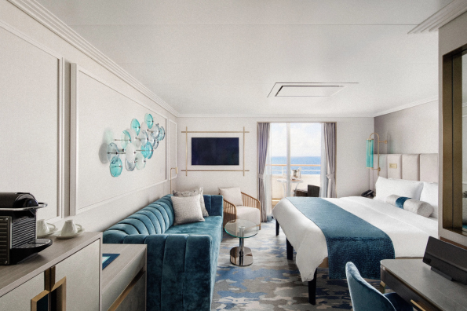
• Sizeable living area with TV
• Queen-size bed or twin beds with sumptuous bedding
• Vanity in dressing area
• Walk-in closet
• Classic suite features a separate soaking bathtub
• Afternoon canapes
• Nespresso coffee maker
• Binoculars

ราคาห้องพัก
DOUBLE GUEST ROOM WITH VERANDA | ราคาต่อท่าน
พัก 1 ท่าน | 11,200 USD
พัก 2 ท่าน | 6,600 USD
ห้องพักขึ้นอยู่กับจำนวนห้องที่เหลืออยู่และอัตราแลกเปลี่ยน USD
ราคาห้องพักที่แสดงเป็นราคาเริ่มต้นเท่านั้น ราคาต้องทำการ Request a quote ทุกครั้งที่ทำการจอง

DOUBLE GUEST ROOM WITH VERANDA
SUITE UP TO 215 SQ | VERANDA UP TO 54 SQ FT
Contemporary bedroom redesigned in 2023, with butler service
and comfortable seating constellations opening onto a private veranda.
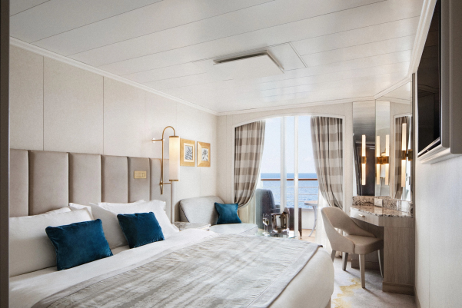
• Private veranda
• Sizeable living area with sofa and TV
• Queen-size bed or twin beds with sumptuous bedding
• Walk-in shower

ราคาห้องพัก
DOUBLE GUEST ROOM WITH OCEAN VIEW | ราคาต่อท่าน
พัก 1 ท่าน | 9,500 USD
พัก 2 ท่าน | 5,600 USD

ห้องพักขึ้นอยู่กับจำนวนห้องที่เหลืออยู่และอัตราแลกเปลี่ยน USD
ราคาห้องพักที่แสดงเป็นราคาเริ่มต้นเท่านั้น ราคาต้องทำการ Request a quote ทุกครั้งที่ทำการจอง

DOUBLE GUEST ROOM WITH OCEAN VIEW
UP TO 215 SQ
Contemporary bedroom redesigned in 2023, with butler service
and impressive windows onto ocean views.
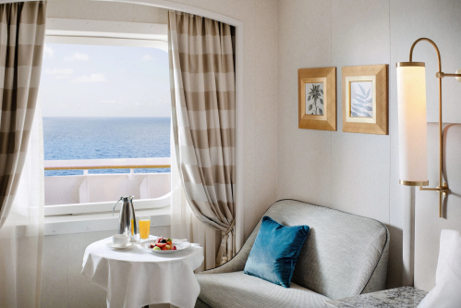
• Large picture window
• Sizeable living area with sofa and TV
• Queen-size bed or twin beds
• Location MID Side

ราคาห้องพัก
SINGLE GUEST ROOM WITH OCEAN VIEW | ราคาต่อท่าน
พัก 1 ท่าน | 7,200 USD
พัก 2 ท่าน | -

ห้องพักขึ้นอยู่กับจำนวนห้องที่เหลืออยู่และอัตราแลกเปลี่ยน USD
ราคาห้องพักที่แสดงเป็นราคาเริ่มต้นเท่านั้น ราคาต้องทำการ Request a quote ทุกครั้งที่ทำการจอง

SINGLE GUEST ROOM WITH OCEAN VIEW
UP TO 215 SQ
Cozy bedroom redesigned in 2023, with welcoming and comfortable
detailing, butler service and ocean views.
• Large picture window
• Sizeable living area with sofa and TV
• Queen-size bed or twin beds with sumptuous bedding
• Walk-in shower
• Location FWD Side

ราคา Cruise Ticket นี้รวม
- ห้องพักบนเรือสำราญ
- ค่าภาษีท่าเรือ

ราคา Cruise Ticket นี้ไม่รวม
- ค่าตั๋วเครื่องบิน
- ค่าทัวร์เสริมบนฝั่งตามเมืองต่างๆ ที่นอกเหนือ
- อาหารพิเศษที่ท่านสั่งเพิ่มเติมกับทางเรือ / บริการพิเศษที่เรืออาจมีค่าใช้จ่าย
- ค่าทำหนังสือเดินทาง , ค่าวีซ่า
- ค่าใช้จ่ายส่วนตัวอื่นๆ เช่น ค่าซักรีด ค่าโทรศัพท์ ค่าเครื่องดื่ม ฯลฯ
- ค่าภาษีมูลค่าเพิ่ม 7% และภาษีหัก ณ ที่จ่าย 3%

